Device Characterization Platform v1.0.0

User Guide

DCP-Authority-User-Guide-v1.0.0

October 4, 2019

Revision history

|  |  |  |
| --- | --- | --- |
| Revision | Date | Description |
| A | October 2019 | Initial release |

**Contents**

1. Introduction 5

1.1. Purpose 5

1.2. Supported Desktop Browsers 5

1.3. Supported Mobile Browsers 5

1.4. Definitions, Acronyms, and Abbreviations 6

2. System Description 7

3. System Navigation 9

3.1. Login Screen 9

3.2. Portal Sections 10

3.3. Dashboard Screen 11

3.4. IMEI Search 12

3.4.1.Matched Devices 15

3.4.2.Counterfeit Devices 17

3.5. My Activity 20

3.6. All Users Activity 21

3.7. Counterfeit Devices 23

3.8. Add Members 25

3.9. App Download 29

3.10. License Agreement 31

3.11. System Feedbacks 33

**Figures**

Figure 1-Login Screen 9

Figure 2-Portal Sections 10

Figure 3-Dashboard Screen 11

Figure 4-IMEI Search 12

Figure 5-IMEI Search 13

Figure 6-Searched Details Table 14

Figure 7-Matched Devices 15

Figure 8-Confirmation Message 16

Figure 9-Report Device 17

Figure 10-Counterfeit Device Details 18

Figure 11-Confirmation Message 19

Figure 12-My Activity 20

Figure 13-All Users Activity 21

Figure 14-Export Activity Logs 22

Figure 15-Counterfeit Devices 23

Figure 16-Export Counterfeit Logs 24

Figure 17-Add Members 25

Figure 18-Add User Details 26

Figure 19-Activate User Account 27

Figure 20-Action Buttons 28

Figure 21- Download Mobile App 29

Figure 22-Download Mobile App 30

Figure 23-License Agreement 31

Figure 24-License Agreement 32

Figure 25-System Feedback 33

**Tables**

Table 1- Supported Desktop Browsers 5

Table 2- Supported Mobile Browsers 5

Table 3- Definitions, Acronyms, and Abbreviations 6

Table 4-System Description 7

# **Introductio****n**

Device Characterization Platform (DCP) is a platform for authorized users to characterize devices based on their IMEI by querying GSMA IMEI database. It fetches information associated with an IMEI from GSMA IMEI database and displays to user. It gives option to user to report counterfeit device if its TAC part of IMEI is not approved by GSMA or characteristics retrieved from GSMA IMEI database does not match with physical device.

## Purpose

This document is intended to give assistance to the user to use the Device Characterization Platform (DCP).

## Supported Desktop Browsers

Table - Supported Desktop Browsers

|  |  |
| --- | --- |
| **Name** | **Version** |
| Internet Explorer | 11.0 |
| Firefox 52.5 ESR | 57.0 |
| Chrome | 63.0 |
| Safari | 11.0 |
| Edge | 41.16299 |

## Supported Mobile Browsers

Table - Supported Mobile Browsers

|  |  |
| --- | --- |
| **Name** | **Version** |
| Chrome | 63.0 |
| UC Browser | 11.5 |
| Opera(Android) | 44.1 |
| Opera(iOS) | 16.0.7 |
| Safari | 11.1 |
| Samsung Internet | 6.2 |
| Android | 4.1.x - 4.3 |

## Definitions, Acronyms, and Abbreviations

Table - Definitions, Acronyms, and Abbreviations

|  |  |
| --- | --- |
| ****Term**** | ****Definition**** |
| **DCP** | **Device Characterization Platform** |
| **TAC** | **Type Allocation Code** |
| **IMEI** | International Mobile Equipment Identity |

# **System Description**

Table **-System Description**

|  |  |
| --- | --- |
| Feature****/Sections**** | ****Description**** |
| **Login Screen** | * In order to gain access to information and functionality, user first needs to enter his/her credentials on login screen. |
| Portal Sections | **The portal is divided into following sections.**   * **Header**   Header section displays name of the system, language change option and name of the logged in user with logout functionality.     * **Navigation Panel**   Navigation Panel contains main navigation menu through which user can navigate the whole system.   * **Main Content Area**   Main Content Area contains all the content to be displayed and actions to be performed for respective feature.   * **Footer**   Footer contains the copyright statement. |
| Dashboard | The dashboard gives the visual display of stats (i.e. statistics, charts, table and heat maps) at a glance. |
| IMEI Search | Allows user to enter IMEI to fetch details from GSMA IMEI database |
| Device Status | Displays the following information (i.e. Device ID, Manufacturer, Equipment Type, Brand Name, Model Name, Marketing Name, Internal Model Name, TAC Approved Date, Device Certify Body, Radio Interface, Operating System, SIM Support, Bluetooth Support, and WLAN Support) of the device in a table. |
| My Activity | Allows user to view his/her own activity logs (i.e. User Device (web, mobile), Checking Method (auto, manual), IMEI Number, Result Status (found/not found), Results Matched(yes/no), User Name, Created At). |
| All Users Activity | * Allows user to view all activity logs of all other users. |
| Counterfeit Devices | * Allows user to search, delete, and view the devices that have been reported as counterfeit |
| Members | * Allows admin user to create a new user and view/edit profile of users. |
| App Download | * Allows user to download the mobile app by accepting the end user license agreement. |
| License Agreement | * Allows user to view current license agreement and add new version of license agreement |
| System Feedbacks | * Allows admin to view the feedback of users. |
| Language Change | * Facilitates user to select any language (English, Vietnamese) for the system. |

# System Navigation

# Login Screen

1. Enter username and password in respective fields
2. Click on “Log in” button

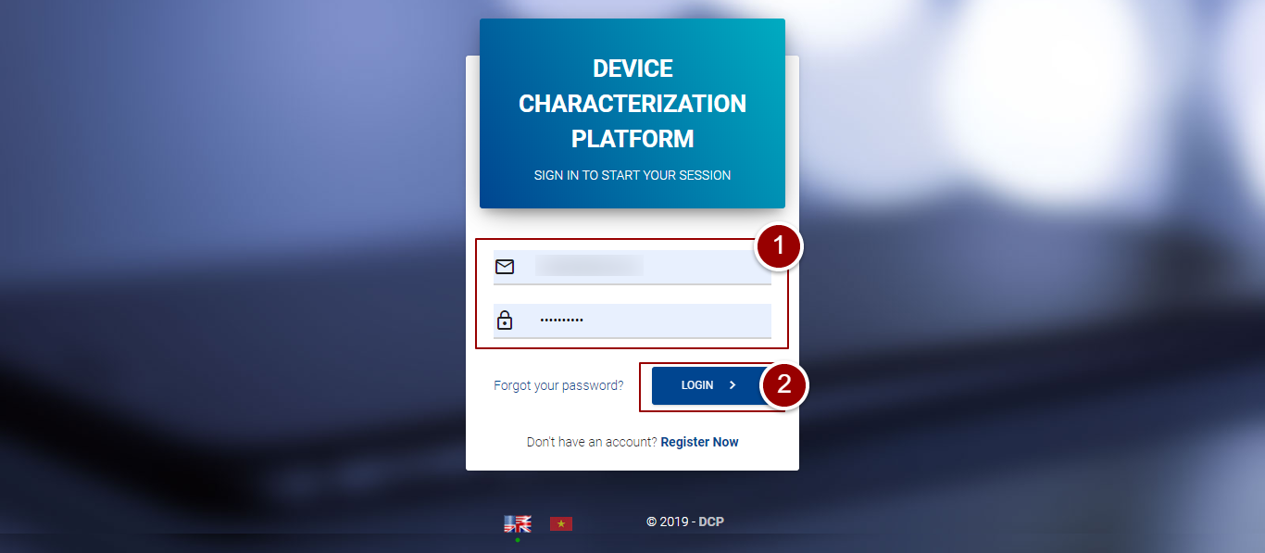

**Figure 1-Login Screen**

# **Portal Sections**

The portal screen is divided into following sections:

1. **Header** section displays name of the system, name of the logged in user with logout functionality.
2. **Main Navigation Panel** helps user to navigate through system.
3. **Main Content Area** contains all relevant information related to the respective feature/option.
4. **Footer** contains the version and copyrights statement.

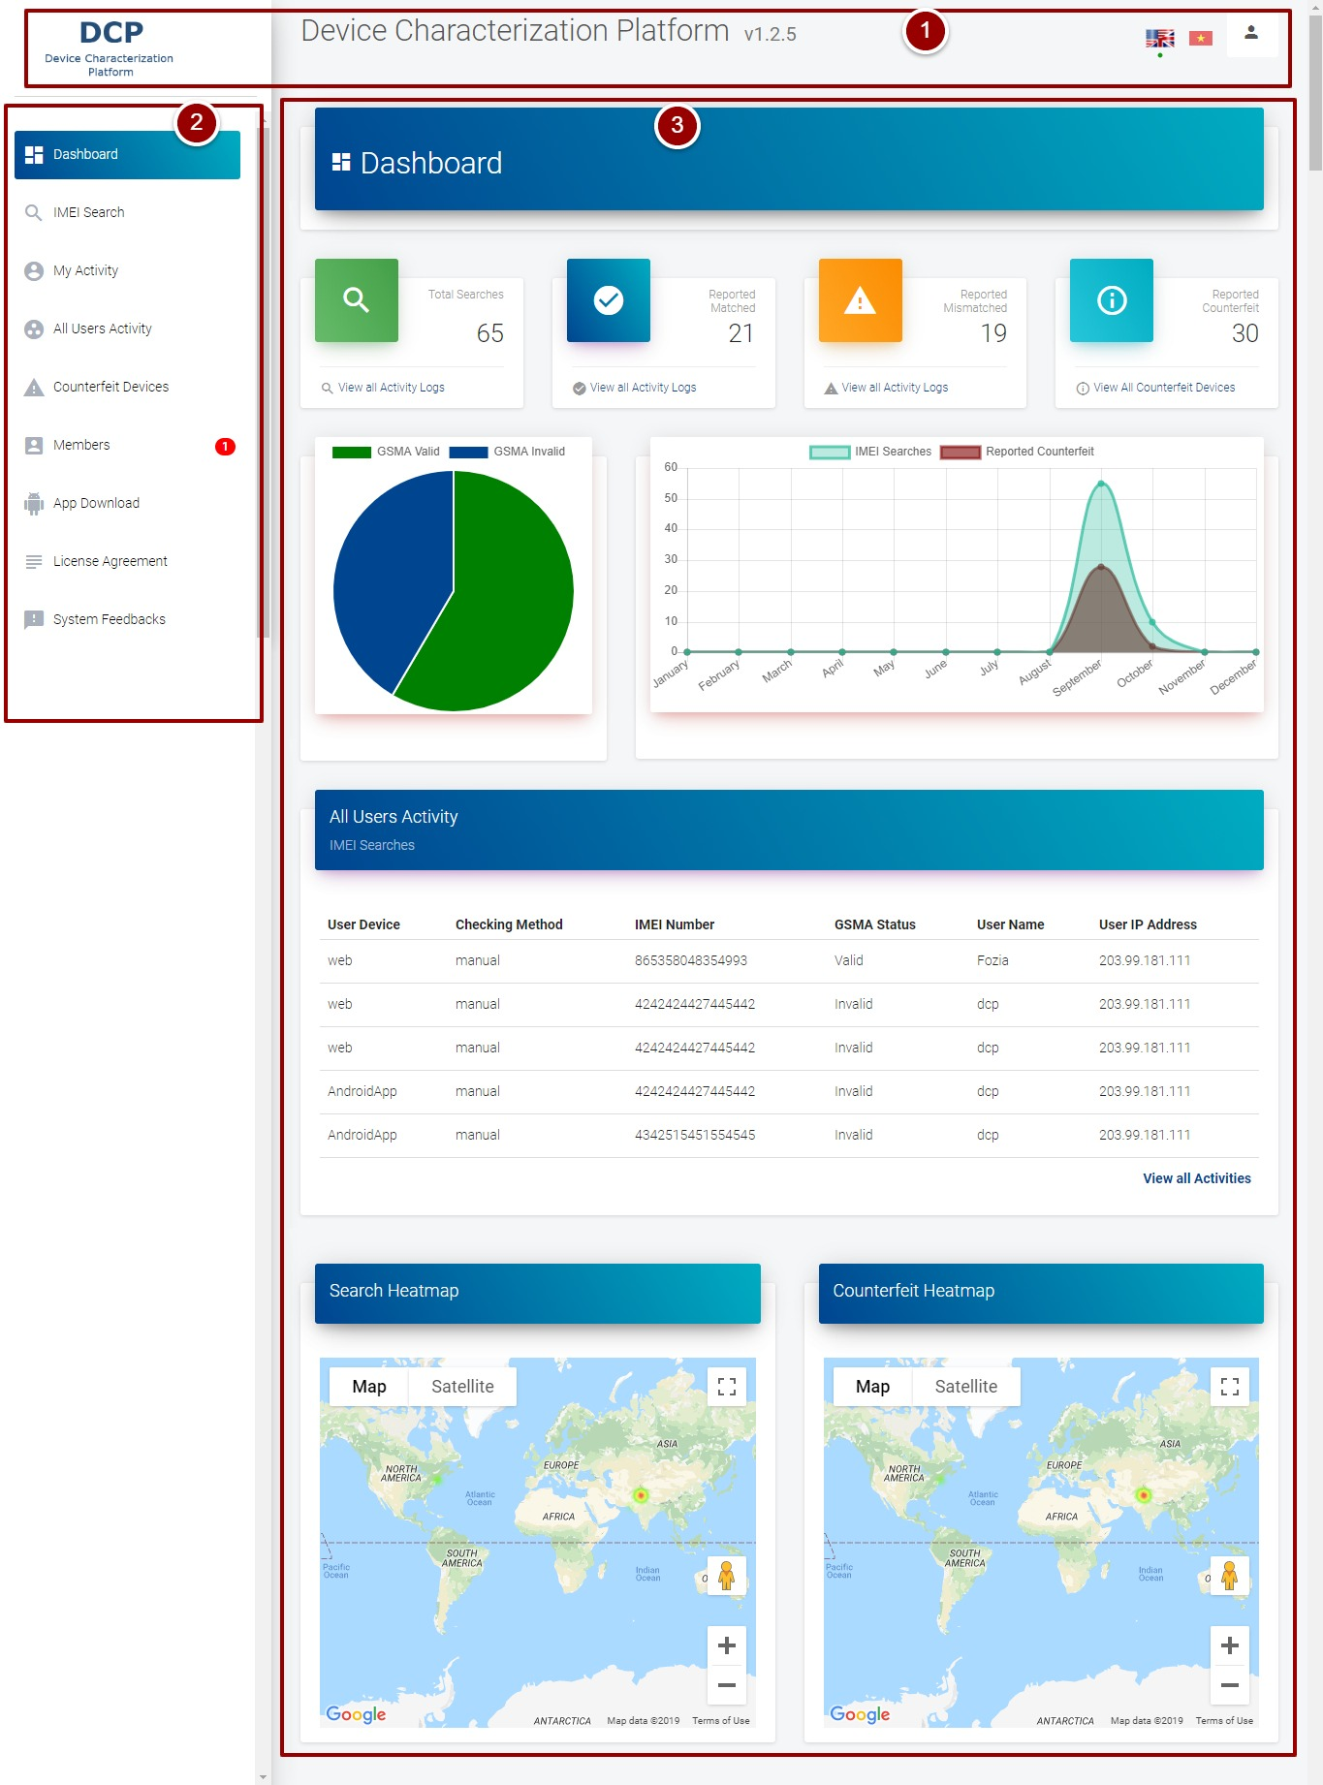

**Figure 2-Portal Sections**

# **Dashboard Screen**

By clicking on “Login” button, it will redirect user to dashboard screen that displays all stats of the system.

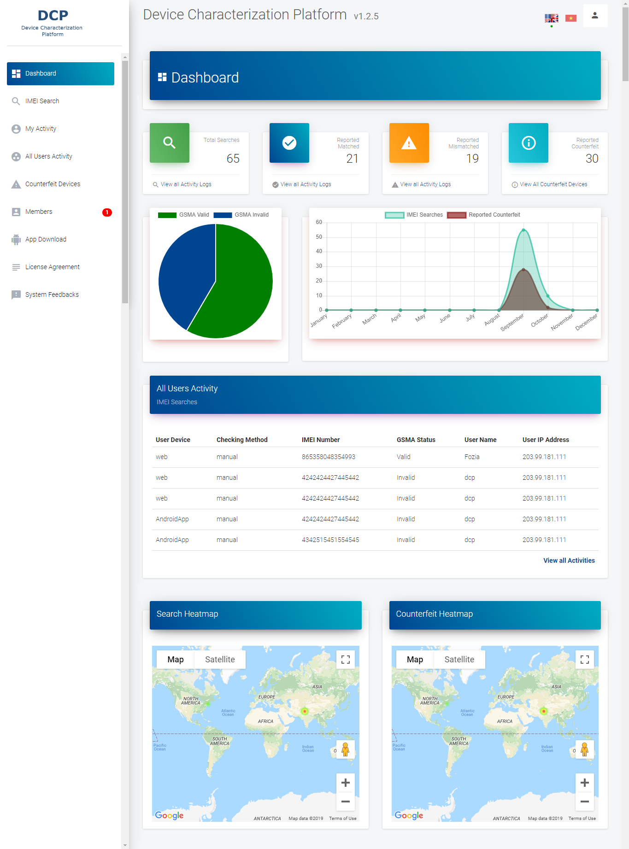

**Figure 3-Dashboard Screen**

# **IMEI Search**

1. To search a particular IMEI, click on “IMEI Search” link
2. Enter IMEI in the respective field

**Note**: The length of the IMEI should be between 14-16 characters.

1. Click on “Search” button

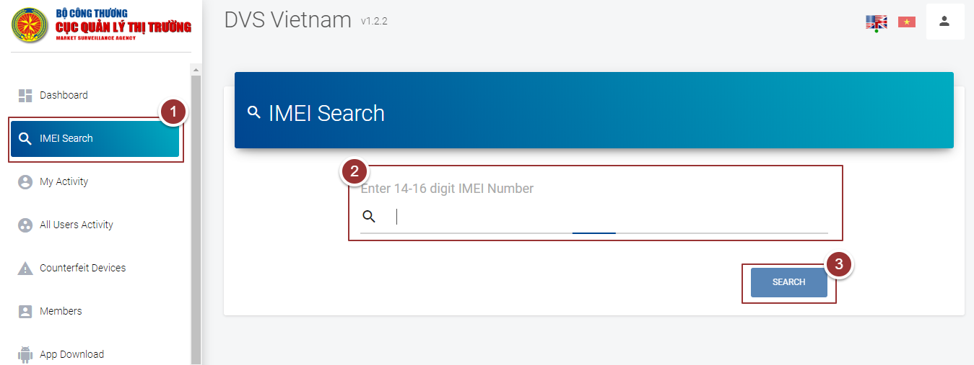

**Figure 4-IMEI Search**

By clicking on “Search” button a popup will appear that contain entered IMEI to be verified.

1. Verify the IMEI and click on “OK” button

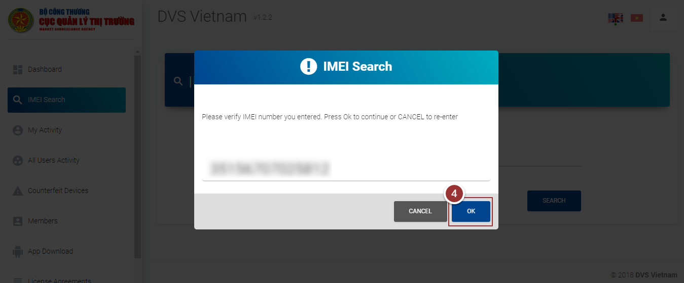

**Figure 5-IMEI Search**

The details of the searched IMEI (i.e. Device ID, Manufacturer, Equipment Type etc.) will display in a table.

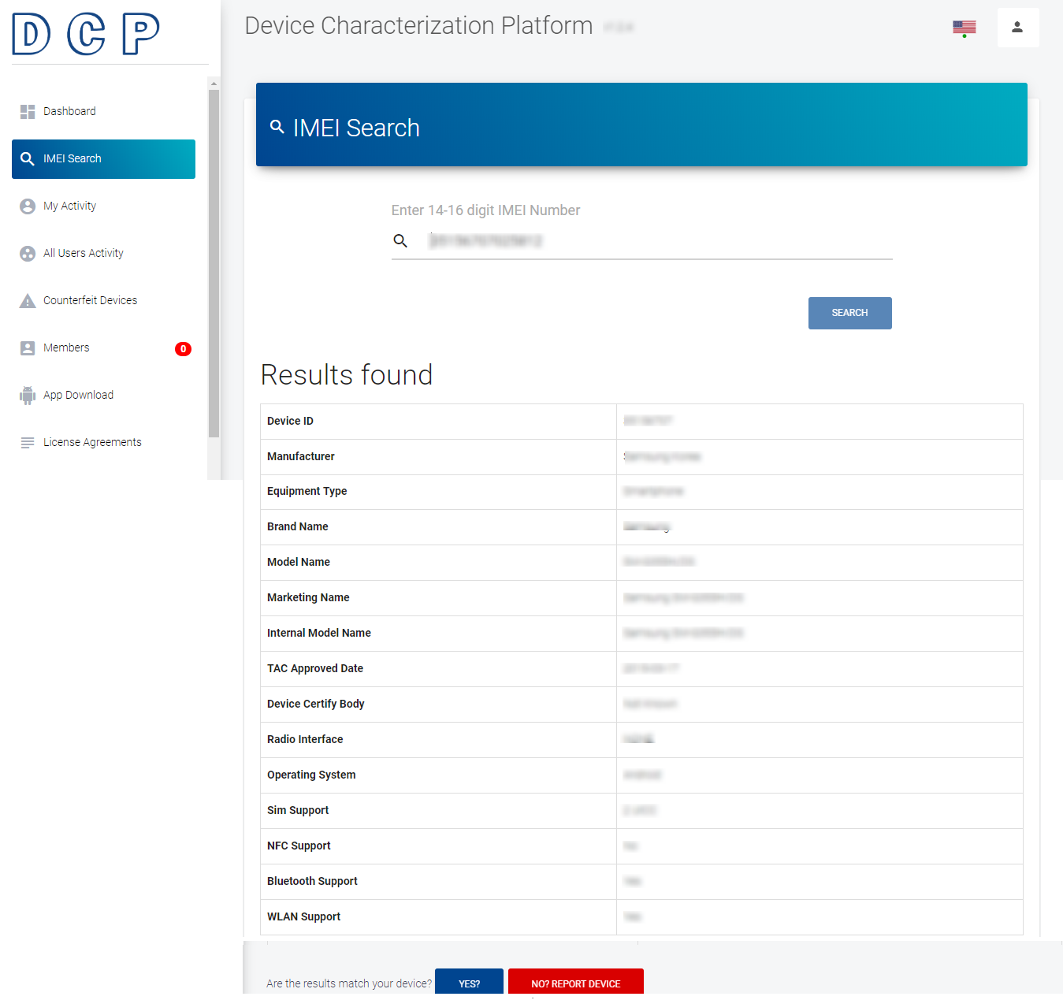

**Figure 6-Searched Details Table**

# **Matched Devices**

**Note**: Repeat steps 1-4 as per section 3.4

If the searched details of the device are matched with user’s device then user can mark the device as matched device.

1. To mark IMEI as matched, click on “Yes” button

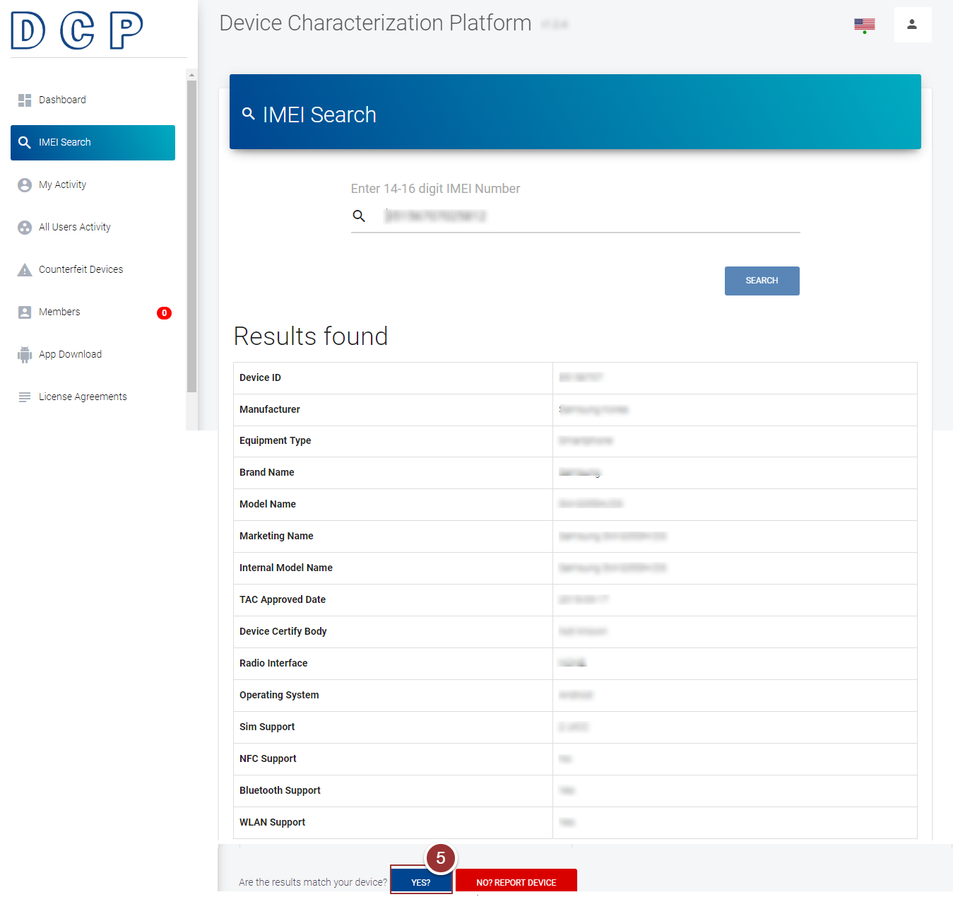

**Figure 7-Matched Devices**

By clicking on “Yes” button, a popup window will appear that displays the confirmation massage.

1. Click on “OK” button to proceed further

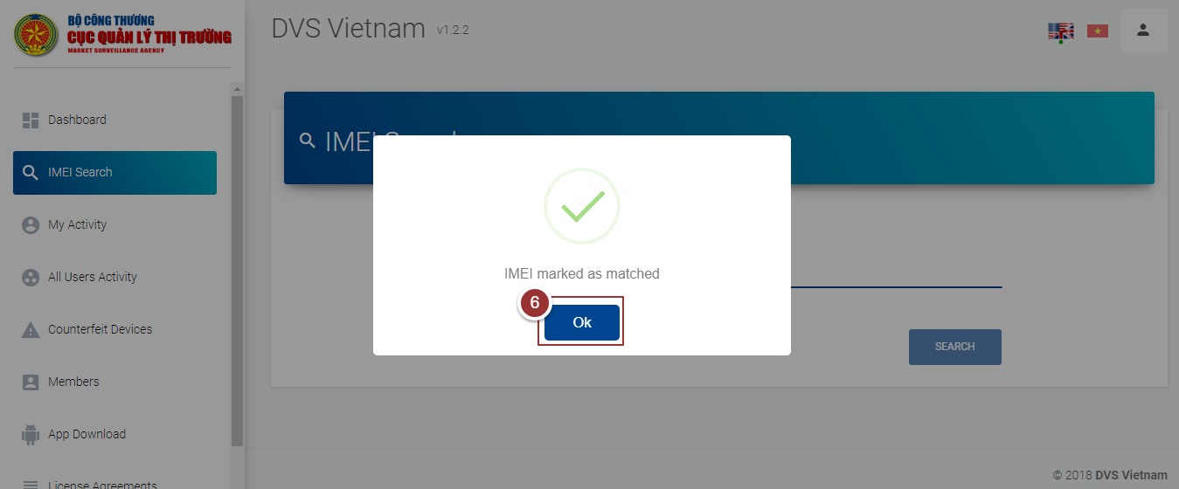

**Figure 8-Confirmation Message**

# **Counterfeit Devices**

**Note:** repeat steps 1-4 as per section 3.4

If the searched details of device are not found/not matched with user’s device then user can report the device as counterfeit device.

1. To report device as counterfeit, click on “Report Device” button

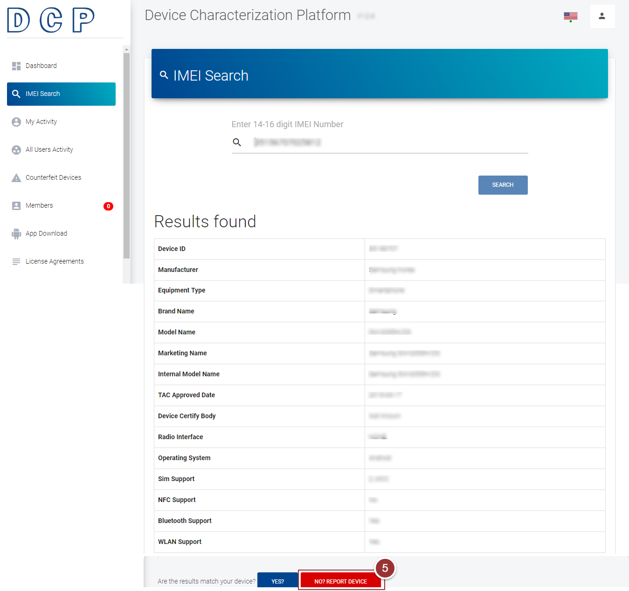

**Figure 9-Report Device**

By clicking on “Report Device” button, a form will appear to get actual details of the device.

1. Enter the required information (i.e. Mobile Phone Brand, Model Name, Store Name, Address(user’s address), Description and images) in the respective fields

**Note**: User can upload maximum 5 images in (.png, .jpg, .gif .jpeg) format.

1. Click on “Submit” button

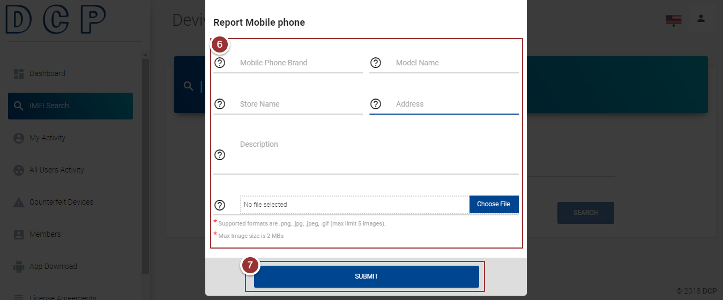

**Figure 10-Counterfeit Device Details**

By clicking on “Submit” button, a popup window will appear that displays the confirmation massage.

1. Click on “OK” button to proceed further

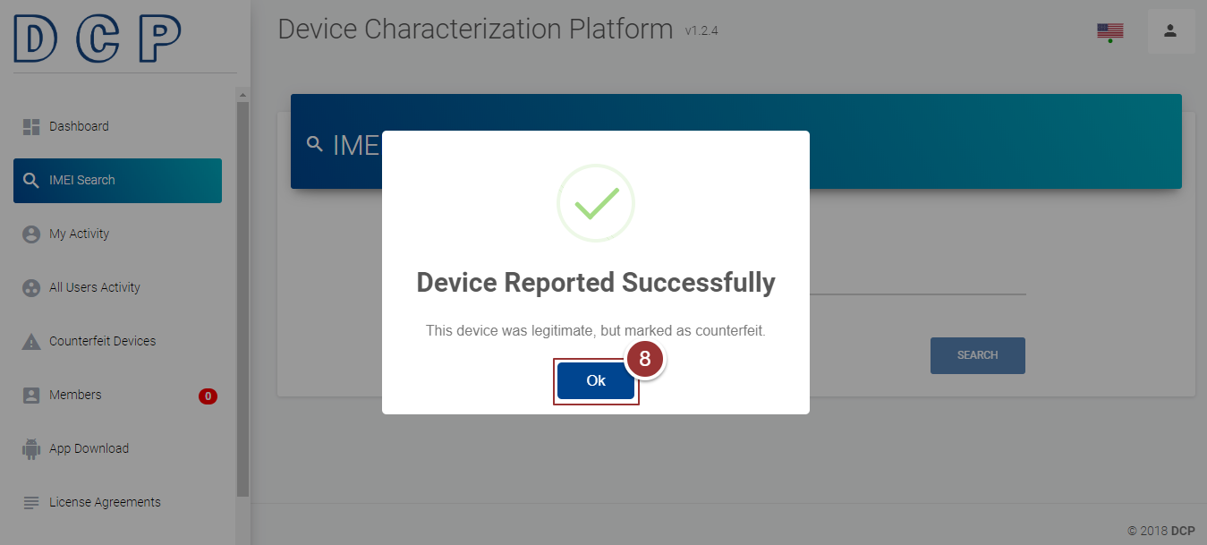

**Figure 11-Confirmation Message**

# **My Activity**

1. To view activity logs(i.e. total number of IMEIs searched by the user), click on the “My Activity” link

A page will appear in the right content area that displays all activity details (i.e. User Device (web, mobile), Checking Method (auto, manual), IMEI Number, Result Status (found/not found), Results Matched(yes/no), User Name, Created At).

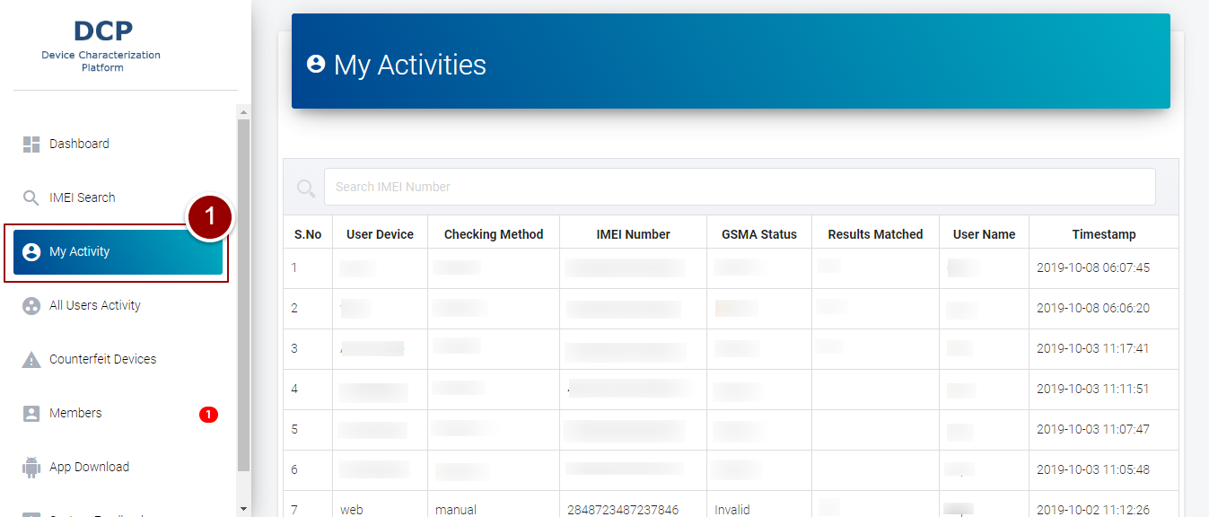

**Figure 12-My Activity**

# **All Users Activity**

1. To view activity logs of all other users, click on “All Users Activity” link

A page will appear in the right content area that displays all activity details.

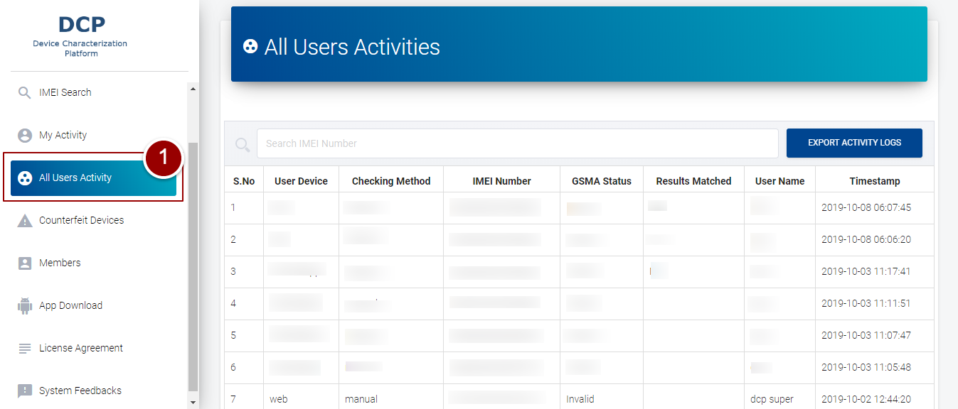

**Figure 13-All Users Activity**

1. To download activity details of all users, click on the “Export Activity Logs” button

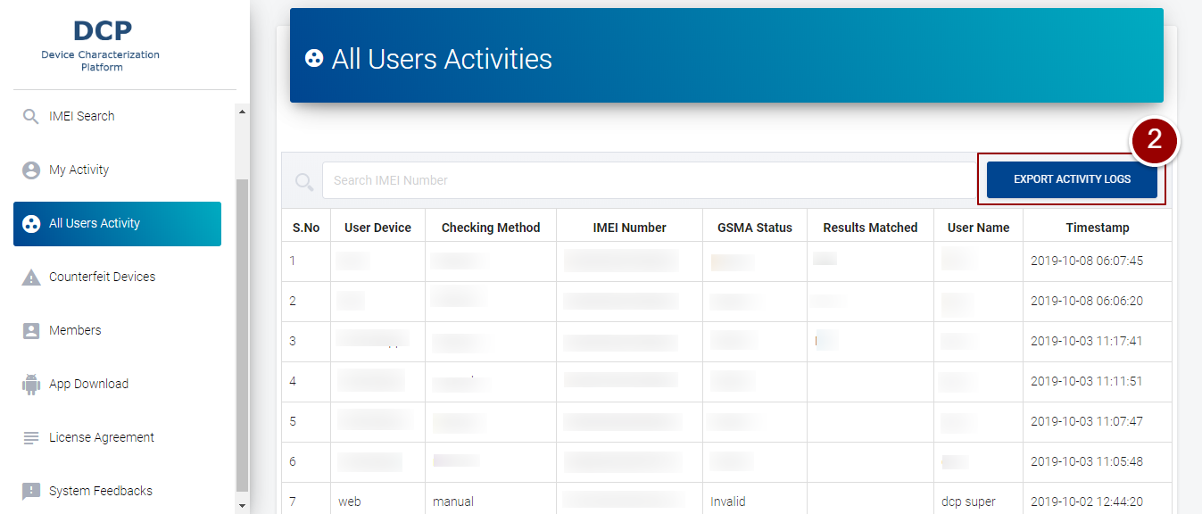

**Figure 14-Export Activity Logs**

# **Counterfeit Devices**

1. To view all counterfeit devices (i.e. Not matched or Not found), click on “Counterfeit Devices” link

A page will appear in right content area that displays information (i.e. IMEI Number, User Name, Brand Name, Model Name, Status, time and date) of counterfeit devices.

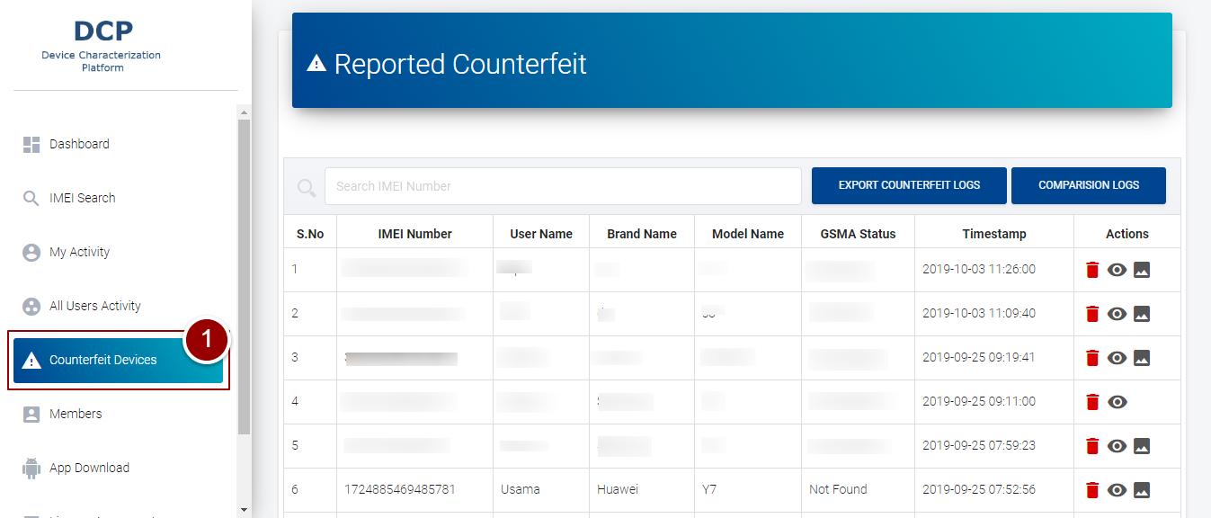

**Figure 15-Counterfeit Devices**

1. To delete/view the log of counterfeit device, click on the required action button
2. To download all details of counterfeit devices, click on the “Export Counterfeit Logs” button
3. To download all details of comparison Logs, click on the “Comparison Logs”

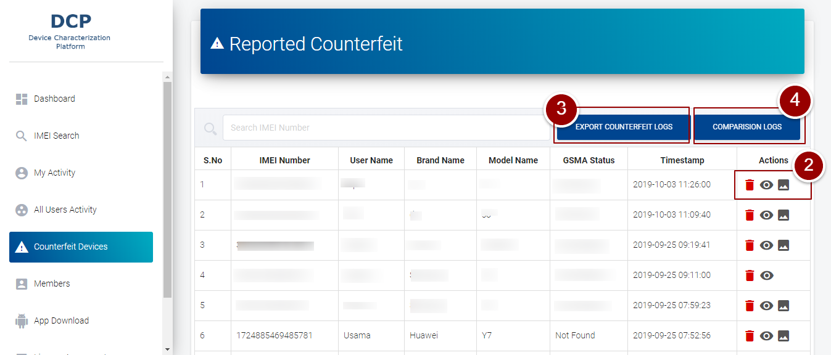

**Figure 16-Export Counterfeit Logs**

# **Add Members**

1. To create a new user, click on “Members” link

A page will appear in right content area that displays the information (i.e. First Name, Last Name, Email Address, and Date/Time Added) of created users.

1. Click on “Add New User” button

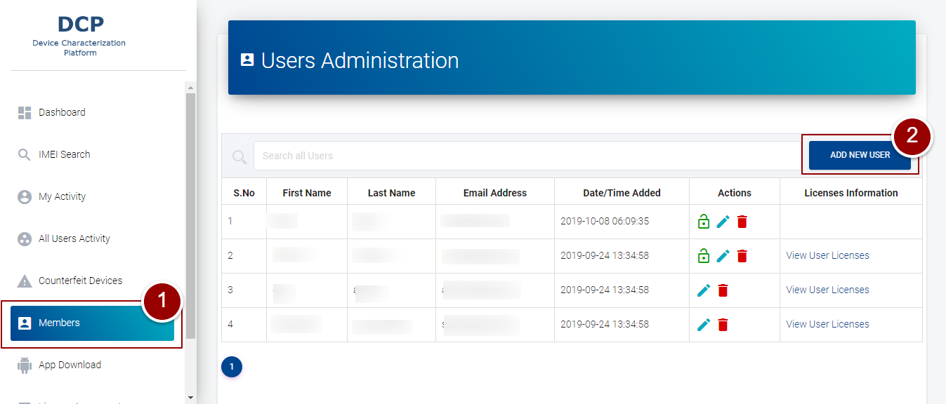

**Figure 17-Add Members**

1. A form will appear to get details of the user (i.e. First Name, Last Name, Email, and password)
2. Click on “Add” button

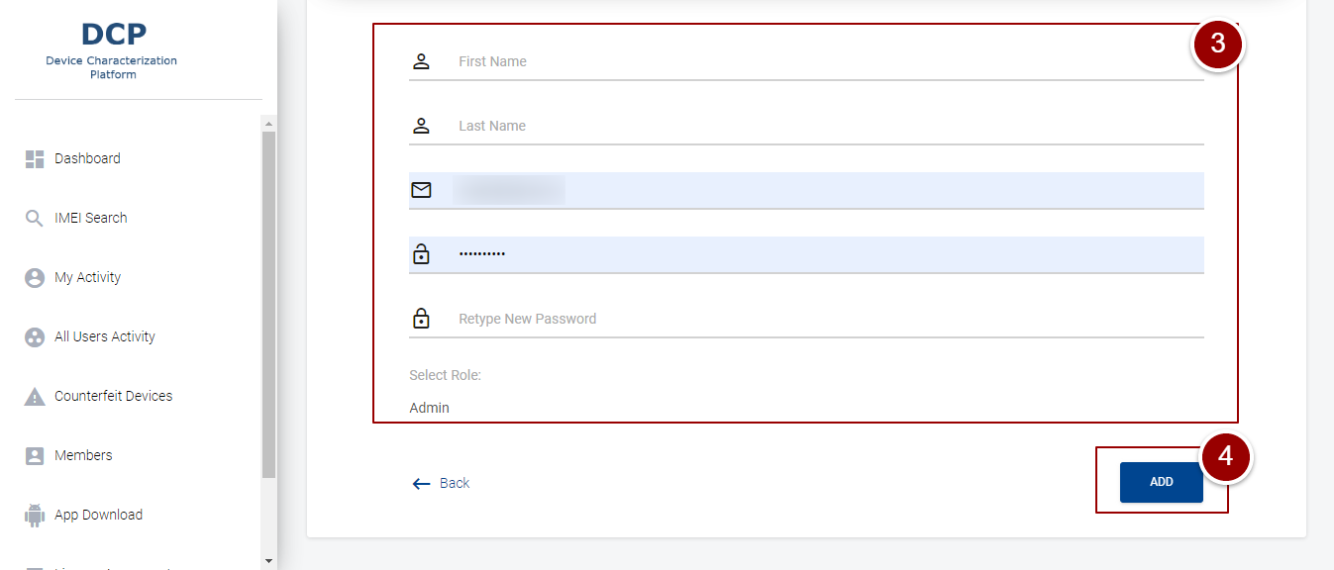

**Figure 18-Add User Details**

1. To approve the request of user account, click on lock icon

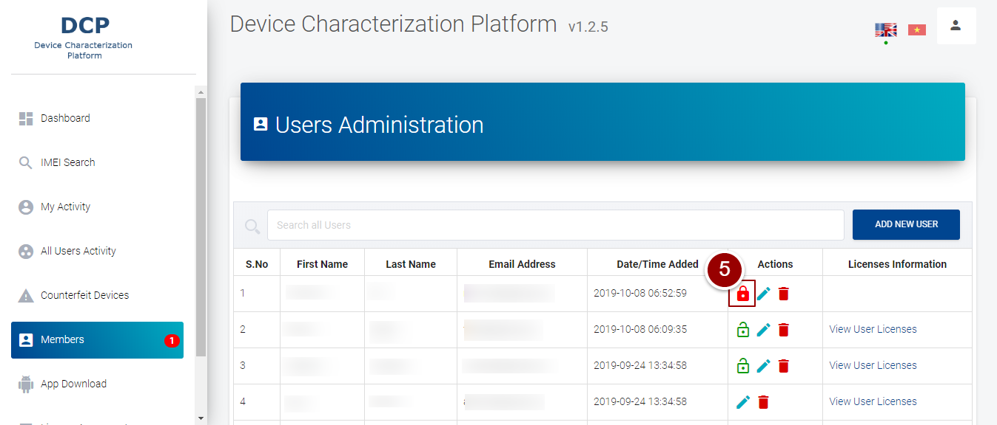

**Figure 19-Activate User Account**

1. To edit information or delete the created user, click on required action button

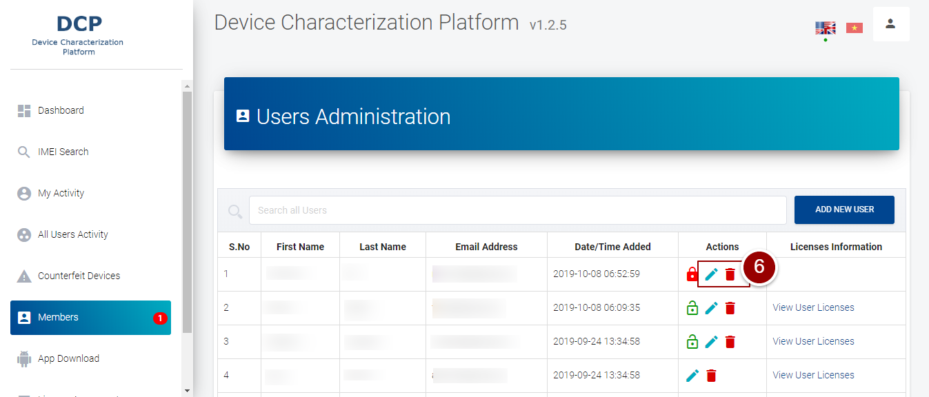

**Figure 20-Action Buttons**

# **App Download**

1. To download mobile app, click on “App download” link

A license agreement will appear in right content area. After accepting the license agreement user will be able to download the mobile app.

1. To accept the license agreement, click on checkbox

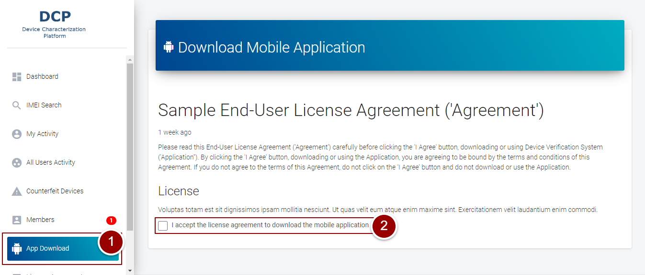

**Figure 21- Download Mobile App**

By clicking on checkbox, a button will appear on the page.

1. Click on “Download” button

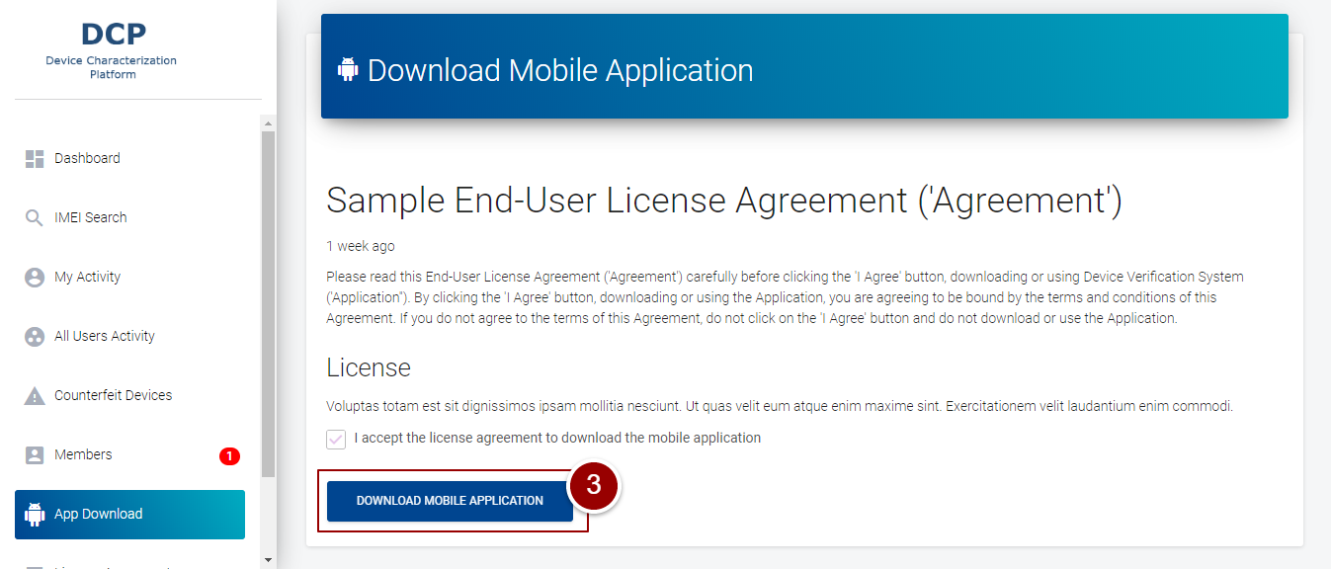

**Figure 22-Download Mobile App**

# **License Agreement**

1. To add new license, click on “License Agreement” link

A page will appear in right content area that displays created licenses.

1. Click on “Add New License” button

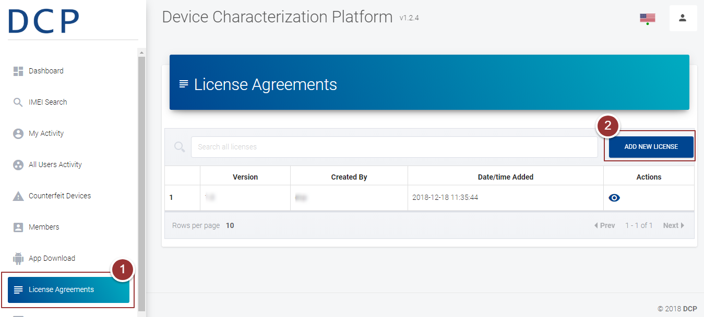

**Figure 23-License Agreement**

1. Enter the details of license (i.e. License Version, License Content) in the respective fields
2. Click on “Agree License Agreement” button

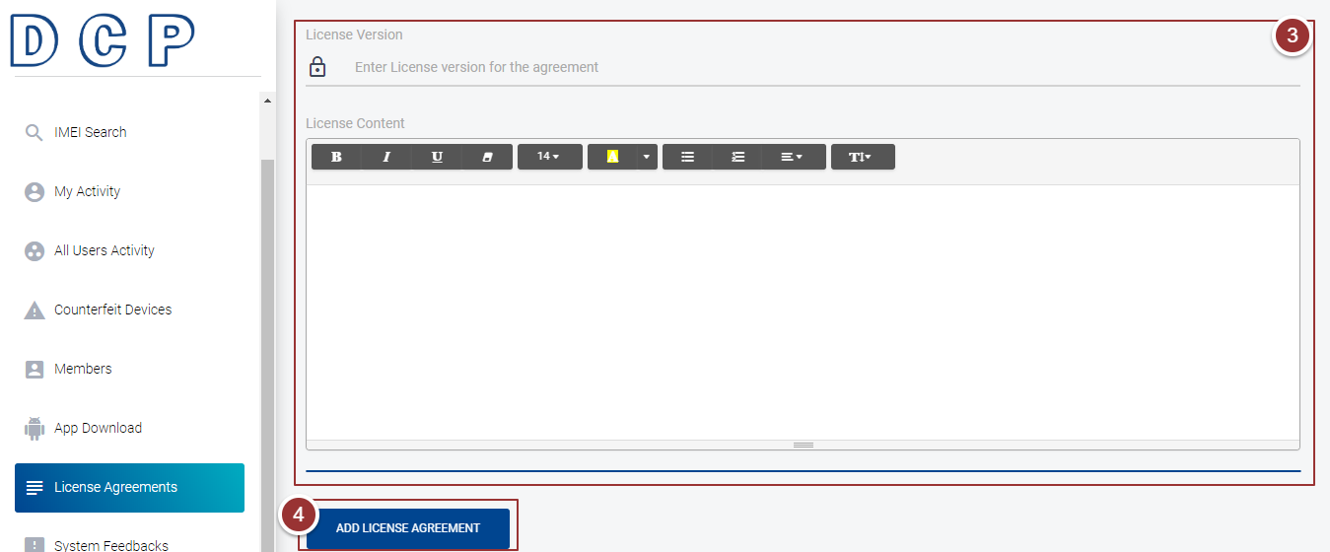

**Figure 24-License Agreement**

# **System Feedbacks**

1. To view feedback of users, click on “System Feedbacks” link

A page will appear in right content area that displays all user’s feedback.

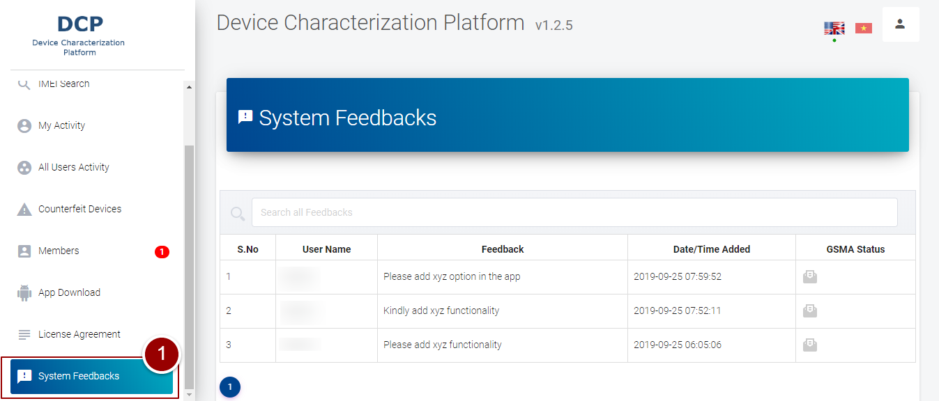

**Figure 25-System Feedback**